***International Baccalaureate Programme  
Hephzibah High School******Language Policy***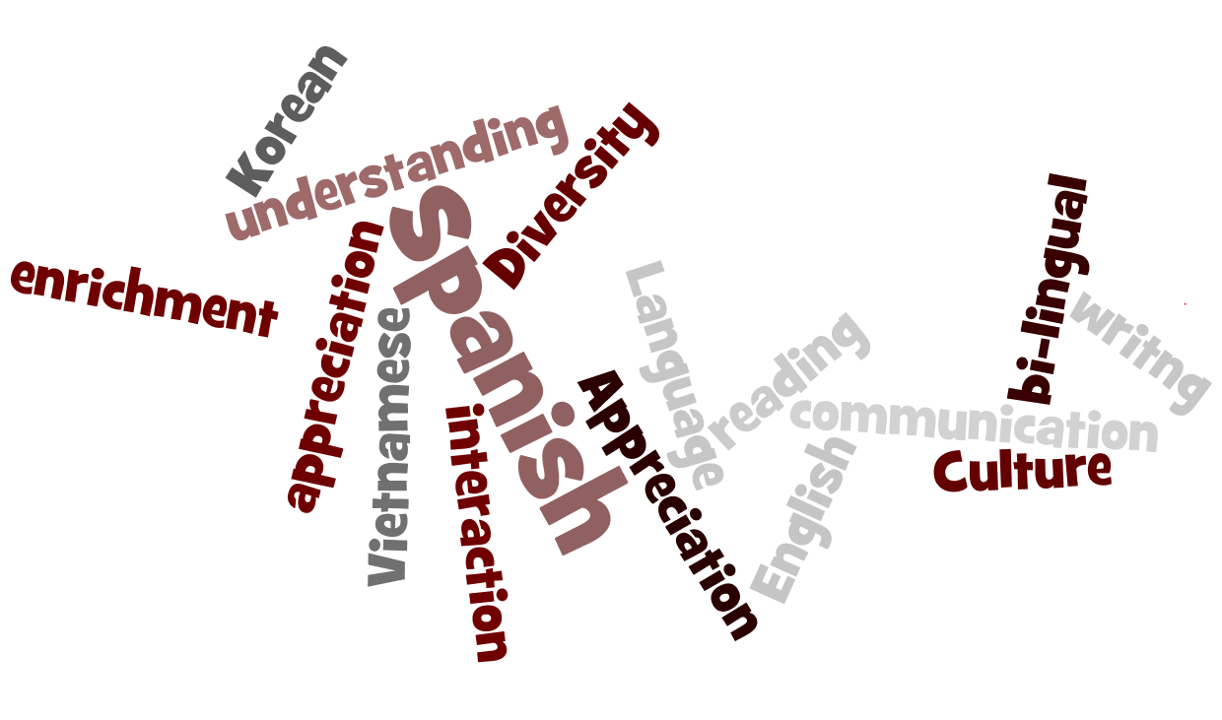

At the Hephzibah High School (HHS), we believe that the development of language and literacy skills is of the highest priority. It is important that children and parents recognize that language is the main tool of learning and communication. As such, the purpose of this language policy is to:

1. Ensure the effective delivery of the Georgia Performance Standards of Excellence and the International Baccalaureate curriculum.
2. Ensure language skills are developed and used across the whole curriculum.
3. Aid the monitoring of the teaching and learning of language.

The language of instruction at HHS is English and the aim is that students work successfully within the English medium. The HHS Language Policy was developed by a team of school community members including the IB Coordinator, teachers, and parents. This document will be made available via the school’s website: [http://www.rcboe.](http://www.rcboe.org/arc)org/hms.

**PHILOSOPHY**

The mission of the Richmond County School System is to build a world-class school system through education, collaboration and innovation. Our school’s vision is to create a world-class, globally competitive school where all students will graduate and are college/career ready. The IB Programme’s mission is to develop inquiring, knowledgeable and caring young people who help to create a better and more peaceful world through intercultural understanding and respect. These interrelated goals can ultimately be achieved as long as educators recognize that language is central to learning. At HHS, we believe that:

1. Language is the fundamental means of communicating, essential to learning, and developed across disciplines: therefore, all teachers are teachers of language.
2. The acquisition of language is a dynamic, lifelong process that permeates all learning, is a key factor in intellectual growth, and promotes the development of personal understanding and international-mindedness.
3. Learning language, learning about language, and learning through language is the most effective approach to teaching students. Language learning meets and is relevant to student needs within our environment.
4. Effective teaching practice arises from a constructivist approach to learning, allowing students to build on prior knowledge and construct personal meaning.
5. Through meaningful interactions, we communicate with and understand others, the world and ourselves to develop intercultural awareness.
6. The school community is a resource to foster language learning. The acquisition of an additional language enriches personal growth, enhances first language development, and promotes internationalism.

**LANGUAGE PROFILE**

Of the 200,000 residents of Augusta, Georgia, approximately 6% speak a language other than English at home (<http://quickfacts.census.gov/qfd/states/13/13245.html>). The most popular foreign languages spoken at home are Spanish, Korean, and Vietnamese. HMS recognizes the diversity of our students and strives to embrace mother tongue languages.

While teaching and learning are accomplished mainly through the use of the English language, students also have the opportunity to learn Spanish through foreign language courses offered at HMS.

**Aims**

1. Develop the skills of each child to the highest level.
2. Produce confident students able to understand and use appropriately the varieties of language available to them.

**HHS AND LANGUAGE EDUCATION IN THE IB MYP PROGRAMME**

**Admissions**

Admission to the International Baccalaureate Middle Years Programme (IBMYP) is open to all students regardless of race, ethnicity, or mother tongues. The IB MYP at Hephzibah is an inclusive program for all students. Students continue with IB MYP at Hephzibah High with Years 4 and 5.

In the event that a student is new to the English language, the Richmond County School System has established an English as a Second Language program at our high school. Students must contact student services and undertake formal testing in reading and writing in English to qualify for this service.

**Language Learning**

While the primary language used at HMS is English, all students at HMS engage in language acquisition and take at least 50 hours each year of Spanish.

**Mother Tongue Support**

HMS promotes an enriched additional language philosophy whereby:

1. English is acquired in addition to students’ home language.
2. For our English language learner, we support our students and their families as they adjust to a new language, learning environment, and culture.
3. All aspects of our language program require formal, as well as informal assessments. These assessments are used to plan appropriate instruction and to evaluate student progress.

Language learning at the Hephzibah High School (HHS) will follow the philosophy, practices, strategies, and assessment as outlined below.

**Language Practices**

1. All teachers will create a risk-free environment to foster a variety of means of communication. Teachers will encourage students to demonstrate open dialogue in all interactions to understand the world through different lenses in specific disciplines. Teachers will model language through everyday use and directly teaching vocabulary and procedural terms within and across each discipline.
2. Curricula will offer the opportunity for personal choice and uninterrupted time for exploring multiple systems of communication in reading, writing, mathematics, art, music, drama, and movement. There will be opportunities for students to use language for making personal connections and exploring compelling issues. Teachers will plan effective, relevant, and engaging lessons to promote proficiency in all forms of language.

**Responsibilities of Stakeholders**

Effective implementation of the Language Policy requires the cooperation of all stakeholders of the school community.

**Role of School District Administration**

1. Use English as the primary language of communication.
2. Provide funding, facilities, leadership, and resources for the successful implementation of the language policy.
3. Hold administrators accountable for implementation.
4. Attract and retain highly qualified and experienced administrators and teachers.

**Role of School Building Administrators**

1. Use English as the primary language of communication.
2. Provide academic leadership for the school.
3. Share responsibility for oversight, implementation, and revision of the Language Policy and curriculum efforts.
4. Support teachers in their delivery of instruction.
5. Provide a variety of professional development opportunities to better enable teachers to be effective instructors of students with a range of language proficiencies.
6. Promote an embedded professional development model enabling collaboration concerning curriculum, instructional technologies, assessment, and student progress.
7. Observe teachers and provide constructive feedback, materials, planning time and staff development opportunities.
8. Promote communication with parents concerning students’ language development.
9. Promote a co-curricular program that encourages the use and development of English.

**Role of Teachers**

1. Use English as the primary language of communication.
2. Promote communication with parents concerning students’ language development.
3. Promote a co-curricular program that encourages the use and development of English.
4. Teachers are required to engage in professional development in the fields of language learning and teaching.
5. Teachers will be required to implement the language policy to ensure that it becomes a working document.
6. Teachers will engage in collaborative workshops and seminars to ensure that teachers are supported in their role in the development of language.

**Review Process**

The language policy is a working document. Consequently, it will be reviewed, and issues will be addressed when the language policy committee meets twice a year. Acting as stakeholders, the following individuals will be involved: Principal, School Administrators, IB coordinators, and teachers. The revision process will assure that the development of language learning is articulated at the beginning and end of the program.

Data-gathering exercises will be implemented during the review process. These activities could involve informal discussions, questionnaires, observations and student interviews. It requires all members of the school community to reflect on their thoughts and practices regarding language in the school.

**References**

Guidelines for developing a school language policy

Language Policy

Developing a School Language Policy